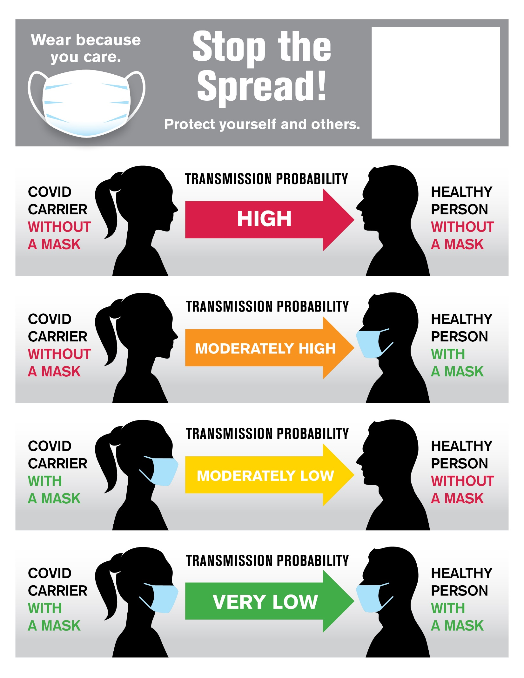

This is a text box.

Erase this text and drop a jpeg or png of your logo in here. Save as a PDF